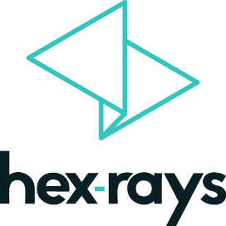
IDA PRO TRAINING ORDER FORM
please fax to +32-4-2235600 or e-mail to sales@hex-rays.com

The training will be held virtually in the CET time zone from 6-10 December and/or 13-15 December 2021
- Standard Training (Using IDA Pro): 6-10 December 2021
- Advanced Training (Programming for IDA): 13-15 December 2021

Attendee information
 | Name & e-mail | License ID | Will attend
 |  |  | Std | Adv
1 |  |  | □ | □
2 |  |  | □ | □
3 |  |  | □ | □
4 |  |  | □ | □
5 |  |  | □ | □

Description | Unit price | # students | Price
Standard Training (using IDA Pro) | 4999 EUR or 5999 USD (5 days)*
Advanced Training (programming for IDA) | 2999 EUR or 3599 USD (3 days)*
Discount 10% (applicable before 31.10.2021)
Total amount and currency
*All prices are VAT excluded. Cancellations are possible before 1st December for a full refund.

Invoicing
Name
Company
Address
Address
City & ZIP Code |  | Country
Phone |  | Fax
VAT number (EU)

Payment Method
Credit Card □ |  | IBAN Transfer □ |  | PO # □
VISA □ | MASTERCARD □
CREDIT CARD #
EXP DATE |  |  | CVC

Signature: Date:

